Impact of budget of the horror movies on its revenue, vote, and the popularity
2023-08-24
Installing the required packaged.
install.packages("tidyverse")
install.packages("ggplot2")
install.packages("datapasta")
install.packages("ggpubr")

R Markdown
library(tidyverse)
## ── Attaching core tidyverse packages ──────────────────────── tidyverse 2.0.0 ──
## ✔ dplyr 1.1.2 ✔ readr 2.1.4
## ✔ forcats 1.0.0 ✔ stringr 1.5.0
## ✔ ggplot2 3.4.3 ✔ tibble 3.2.1
## ✔ lubridate 1.9.2 ✔ tidyr 1.3.0
## ✔ purrr 1.0.2
## ── Conflicts ────────────────────────────────────────── tidyverse_conflicts() ──
## ✖ dplyr::filter() masks stats::filter()
## ✖ dplyr::lag() masks stats::lag()
## ℹ Use the conflicted package (<http://conflicted.r-lib.org/>) to force all conflicts to become errors
library(ggplot2)
library(datapasta)
library(ggpubr)
Importing the datafile from local storage. Data is downloaded from TidyTuesday github repository.
Horror_movies <- read.csv("horror_movies.csv")
Get a overview of the structure of our data
str(Horror_movies)
## 'data.frame': 32540 obs. of 20 variables:
## $ id : int 760161 760741 882598 756999 772450 1014226 717728 762504 927341 760104 ...
## $ original_title : chr "Orphan: First Kill" "Beast" "Smile" "The Black Phone" ...
## $ title : chr "Orphan: First Kill" "Beast" "Smile" "The Black Phone" ...
## $ original_language: chr "en" "en" "en" "en" ...
## $ overview : chr "After escaping from an Estonian psychiatric facility, Leena Klammer travels to America by impersonating Esther,"| __truncated__ "A recently widowed man and his two teenage daughters travel to a game reserve in South Africa. However, their j"| __truncated__ "After witnessing a bizarre, traumatic incident involving a patient, Dr. Rose Cotter starts experiencing frighte"| __truncated__ "Finney Blake, a shy but clever 13-year-old boy, is abducted by a sadistic killer and trapped in a soundproof ba"| __truncated__ ...
## $ tagline : chr "There's always been something wrong with Esther." "Fight for family." "Once you see it, it’s too late." "Never talk to strangers." ...
## $ release_date : chr "2022-07-27" "2022-08-11" "2022-09-23" "2022-06-22" ...
## $ poster_path : chr "/pHkKbIRoCe7zIFvqan9LFSaQAde.jpg" "/xIGr7UHsKf0URWmyyd5qFMAq4d8.jpg" "/hiaeZKzwsk4y4atFhmncO5KRxeT.jpg" "/lr11mCT85T1JanlgjMuhs9nMht4.jpg" ...
## $ popularity : num 5089 2172 1864 1071 1021 ...
## $ vote_count : int 902 584 114 2736 83 1 125 1684 73 1035 ...
## $ vote_average : num 6.9 7.1 6.8 7.9 7 1 5.8 7 6.5 6.8 ...
## $ budget : int 0 0 17000000 18800000 0 0 20000000 68000000 0 10000000 ...
## $ revenue : int 9572765 56000000 45000000 161000000 0 0 2892594 170800000 0 14257609 ...
## $ runtime : int 99 93 115 103 0 0 88 130 90 106 ...
## $ status : chr "Released" "Released" "Released" "Released" ...
## $ adult : logi FALSE FALSE FALSE FALSE FALSE FALSE ...
## $ backdrop_path : chr "/5GA3vV1aWWHTSDO5eno8V5zDo8r.jpg" "/2k9tBql5GYH328Krj66tDT9LtFZ.jpg" "/mVNPfpydornVe4H4UCIk7WevWjf.jpg" "/AfvIjhDu9p64jKcmohS4hsPG95Q.jpg" ...
## $ genre_names : chr "Horror, Thriller" "Adventure, Drama, Horror" "Horror, Mystery, Thriller" "Horror, Thriller" ...
## $ collection : int 760193 NA NA NA NA NA 94899 NA NA 950289 ...
## $ collection_name : chr "Orphan Collection" NA NA NA ...

Variable | Type | Definition | Example
id | int | unique movie id | 4488
original_title | char | original movie title | Friday the 13th
title | char | movie title | Friday the 13th
original_language | char | movie language | en
overview | char | movie overview/desc | Camp counselors are stalked...
tagline | char | tagline | They were warned...
release_date | date | release date | 1980-05-09
poster_path | char | image url | /HzrPn1gEHWixfMOvOehOTlHROo.jpg
popularity | num | popularity | 58.957
vote_count | int | total votes | 2289
vote_average | num | average rating | 6.4
budget | int | movie budget | 550000
revenue | int | movie revenue | 59754601
runtime | int | movie runtime (min) | 95
status | char | movie status | Released
genre_names | char | list of genre tags | Horror, Thriller
collection | num | collection id (nullable) | 9735
collection_name | char | collection name (nullable) | Friday the 13th Collection

We select the variables which is of interest.
sd_horror_movies <- Horror_movies %>% select("id","original_title","original_language","popularity","vote_average","budget","revenue")
We look at our subset data, and we can see that the languages are annotated with abbreviations.
str(sd_horror_movies)
## 'data.frame': 32540 obs. of 7 variables:
## $ id : int 760161 760741 882598 756999 772450 1014226 717728 762504 927341 760104 ...
## $ original_title : chr "Orphan: First Kill" "Beast" "Smile" "The Black Phone" ...
## $ original_language: chr "en" "en" "en" "en" ...
## $ popularity : num 5089 2172 1864 1071 1021 ...
## $ vote_average : num 6.9 7.1 6.8 7.9 7 1 5.8 7 6.5 6.8 ...
## $ budget : int 0 0 17000000 18800000 0 0 20000000 68000000 0 10000000 ...
## $ revenue : int 9572765 56000000 45000000 161000000 0 0 2892594 170800000 0 14257609 ...
To get the actual names of the language from the abbreviations we copy a table from this website: https://www.science.co.il/language/Codes.php and saved it into a new R-script. We converted it into a table.
lang <- data.table::fread("lang", data.table = FALSE, fill = TRUE)
We view our language data:
head(lang)
## Afar aa aar afar
## 1 Abkhazian ab abk abkhaze
## 2 Avestan ae ave avestique
## 3 Afrikaans af afr afrikaans
## 4 Akan ak aka akan
## 5 Amharic am amh amharique
## 6 Aragonese an arg aragonais
Then we join our horror movie data with our language data, but only adding the Afar (language) column:
joined_sd_horror_movies <- left_join(sd_horror_movies, lang, by=c("original_language"="aa")) %>% select(-"aar", -"afar")
Relocating Afar next original language column and renaming Afar to language:
joined_sd_horror_movies <- joined_sd_horror_movies %>% relocate(Afar,.after="original_language") %>% rename(Language=Afar)
We arrange the data to find the top three language of the movies:
joined_sd_horror_movies %>% group_by(Language) %>% summarise(Number=n()) %>% arrange(desc(Number))
## # A tibble: 95 × 2
## Language Number
## <chr> <int>
## 1 English 21923
## 2 Spanish; Castilian 1661
## 3 Japanese 1639
## 4 Portuguese 676
## 5 German 631
## 6 Indonesian 604
## 7 French 591
## 8 Italian 575
## 9 <NA> 523
## 10 Chinese 496
## # ℹ 85 more rows
Making a new dataset with only movies with a budget above 500.000(unit?), vote average above 1 and only of the top three language of movies:
sd_horror_movies_w500000 <- joined_sd_horror_movies %>% filter(budget >= 500000, vote_average > 1, Language=="English"|Language=="Spanish; Castilian"|Language=="Japanese")
We examine whether a larger budget gives the movies a larger revenue by plotting scatter plot of budget vs. revenue for the three top language of movies(English, Japanese, Spanish) and linear regression:
av_vote_revenue_d <- ggplot(sd_horror_movies_w500000, mapping=aes(x=budget, y=revenue, color=Language)) + geom_point() + scale_x_log10() + facet_grid(cols=vars(Language)) + geom_smooth(method="lm", formula=y~log(x), color="black", level=FALSE) + xlab("Budget (Log scale)") + ylab("Revenue") + ggtitle("Budget vs. Revenue") + theme_bw()
av_vote_revenue_d
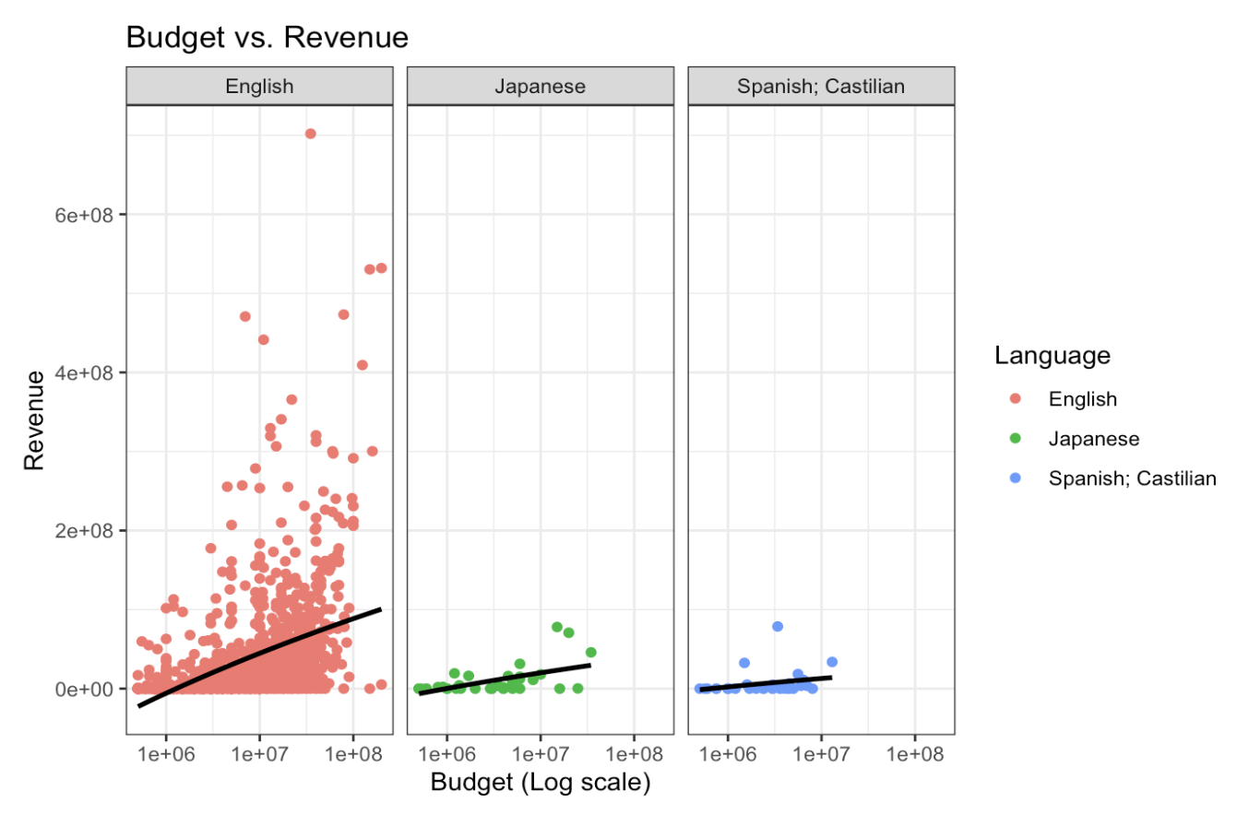
We look into the linear regression for each the top three movie language estimating the R-squared and p-value to test the model fit.
lr1 <- sd_horror_movies_w500000 %>% group_by(Language) %>% do(model=lm(formula=revenue~log(budget), .))
lr1
## # A tibble: 3 × 2
## # Rowwise:
## Language model
## <chr> <list>
## 1 English <lm>
## 2 Japanese <lm>
## 3 Spanish; Castilian <lm>
summary(lr1[[2]][[1]])$coefficients
## Estimate Std. Error t value Pr(>|t|)
## (Intercept) -309387952 14753716.8 -20.97017 2.541957e-86
## log(budget) 21949135 964560.4 22.75558 2.356515e-99
summary(lr1[[2]][[1]])$r.squared
## [1] 0.2471895
summary(lr1[[2]][[2]])$coefficients
## Estimate Std. Error t value Pr(>|t|)
## (Intercept) -121550253 34109251 -3.563557 0.0010800986
## log(budget) 8800481 2282173 3.856185 0.0004722738
summary(lr1[[2]][[2]])$r.squared
## [1] 0.2981775
summary(lr1[[2]][[3]])$coefficients
## Estimate Std. Error t value Pr(>|t|)
## (Intercept) -63932490 46824830 -1.365354 0.1822932
## log(budget) 4785220 3189193 1.500449 0.1439503
summary(lr1[[2]][[3]])$r.squared
## [1] 0.06980626
Putting the R-squared and p-value for each group into a dataframe:
dat_text <- data.frame(
label = c("R = 0.247, p=0.001", "R = 0.298, p=0.001", "R = 0.070, p=0.144"),
Language = c("English", "Japanese", "Spanish; Castilian")
)
Adding the R-squared and p-value for each group into the figure:
av_vote_revenue_d_wn <- ggplot(sd_horror_movies_w500000, mapping=aes(x=budget, y=revenue, color=Language)) + geom_point() + scale_x_log10() + facet_grid(cols=vars(Language)) + geom_smooth(method="lm", formula=y~log(x), color="black", level=FALSE) + xlab("Budget (Log scale)") + ylab("Revenue") + ggtitle("Budget vs. Revenue") + theme_bw() + geom_text(
data = dat_text,
mapping = aes(x = 1e+05, y = 6.3e+08, label = label),
hjust = -0.1,
vjust = -1
)
av_vote_revenue_d_wn
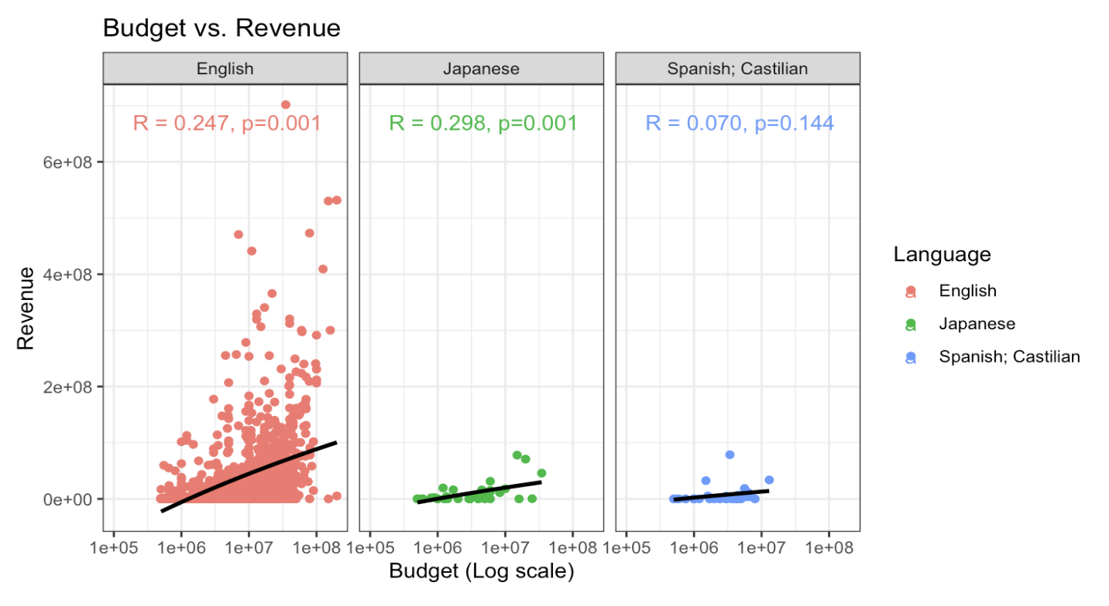
We have budget of the movies on X axis and its revenue on the Y axis. We looked into the top three language movies. Budget of movies in all three language found to have a very low positive correlation with its revenue. However, only English and Japanese movies showed a significant correlation.
We examine whether a larger budget gives the movies a higher vote average by plotting scatter plot of budget vs. vote average for the three top language of movies(English, Japanese, Spanish) and linear regression:
av_vote_budget_d <- ggplot(sd_horror_movies_w500000, mapping=aes(x=budget, y=vote_average, color=Language)) + geom_point() + scale_x_log10() + facet_grid(cols=vars(Language)) + geom_smooth(method="lm", color="black", level=FALSE) + xlab("Budget (Log scale)") + ylab("Vote average") + ggtitle("Budget vs. vote average") + theme_bw()
av_vote_budget_d
## `geom_smooth()` using formula = 'y ~ x'

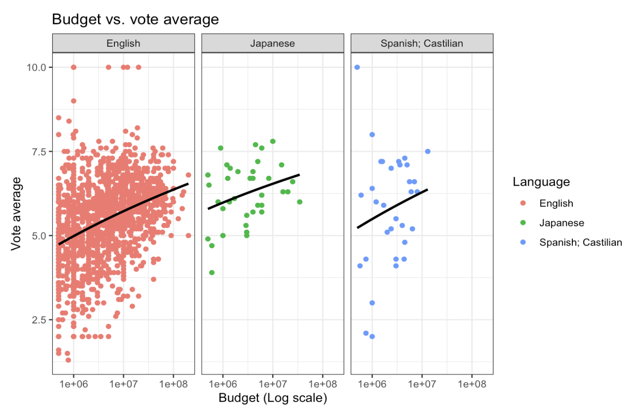
We look into the linear regression for each the top three movie language estimating the R-squared and p-value to test the model fit.
lr2 <- sd_horror_movies_w500000 %>% group_by(Language) %>% do(model=lm(formula=vote_average~log(budget), .))
lr2
## # A tibble: 3 × 2
## # Rowwise:
## Language model
## <chr> <list>
## 1 English <lm>
## 2 Japanese <lm>
## 3 Spanish; Castilian <lm>
summary(lr2[[2]][[1]])$coefficients
## Estimate Std. Error t value Pr(>|t|)
## (Intercept) 0.6812006 0.31564577 2.158117 3.106924e-02
## log(budget) 0.3120145 0.02063612 15.119828 2.467747e-48
summary(lr2[[2]][[1]])$r.squared
## [1] 0.1266106
summary(lr2[[2]][[2]])$coefficients
## Estimate Std. Error t value Pr(>|t|)
## (Intercept) 2.6849932 1.8952101 1.416726 0.1654029
## log(budget) 0.2387745 0.1268042 1.883017 0.0680305
summary(lr2[[2]][[2]])$r.squared
## [1] 0.09198813
summary(lr2[[2]][[3]])$coefficients
## Estimate Std. Error t value Pr(>|t|)
## (Intercept) 0.4234114 5.1962819 0.08148352 0.9355986
## log(budget) 0.3659685 0.3539137 1.03406153 0.3093716
summary(lr2[[2]][[3]])$r.squared
## [1] 0.03441609
Putting the R-squared and p-value for each group into a dataframe:
dat_text2 <- data.frame(
label = c("R = 0.127, p=0.001", "R = 0.092, p=0.068", "R = 0.034, p=0.309"),
Language = c("English", "Japanese", "Spanish; Castilian")
)
Adding the R-squared and p-value for each group into the figure:
av_vote_budget_d_wn <- ggplot(sd_horror_movies_w500000, mapping=aes(x=budget, y=vote_average, color=Language)) + geom_point() + scale_x_log10() + facet_grid(cols=vars(Language)) + geom_smooth(method="lm", color="black", level=FALSE) + xlab("Budget (Log scale)") + ylab("Vote average") + ggtitle("Budget vs. vote average") + theme_bw() + geom_text(
data = dat_text2,
mapping = aes(x = 1e+05, y = 9, label = label),
hjust = -0.1,
vjust = -1
)
av_vote_budget_d_wn
## `geom_smooth()` using formula = 'y ~ x'

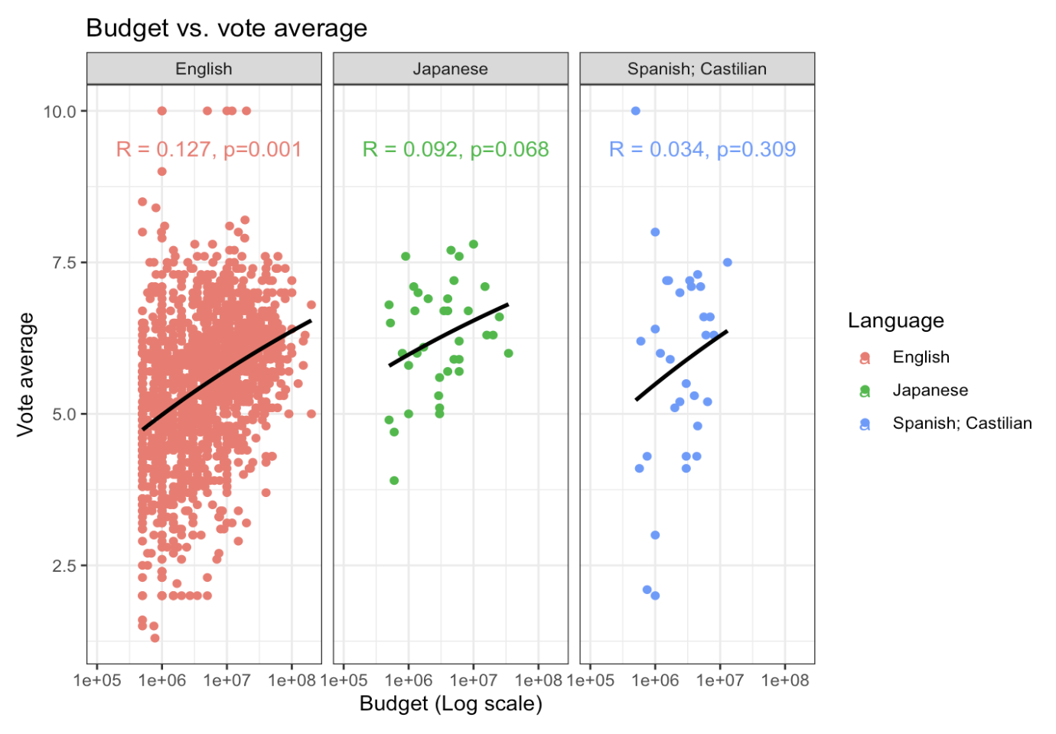
We have budget of the movies on X axis and its vote average on the Y axis. We looked into the top three language movies. Budget of movies in all three language found to have a very low positive correlation with its vote average. However, only English movies showed a significant correlation.
We examine whether larger budget movies has higher popularity by plotting scatter plot of budget vs. popularity for the three top language of movies(English, Japanese, Spanish) and linear regression:
popu_budget_d <- ggplot(sd_horror_movies_w500000, mapping=aes(x=budget, y=popularity, color=Language)) + geom_point() + scale_x_log10() + facet_grid(cols=vars(Language)) + geom_smooth(method="lm", color="black", level=FALSE) + xlab("Budget (Log scale)") + ylab("Popularity") + ggtitle("Budget vs. popularity") + theme_bw()
popu_budget_d
## `geom_smooth()` using formula = 'y ~ x'
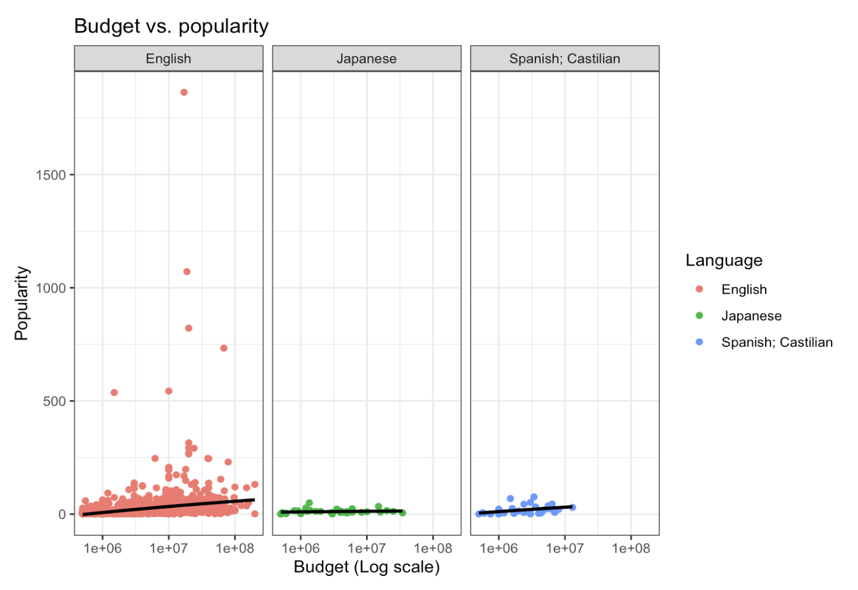
We look into the linear regression for each the top three movie language estimating the R-squared and p-value to test the model fit.
lr3 <- sd_horror_movies_w500000 %>% group_by(Language) %>% do(model=lm(formula=popularity~log(budget), .))
lr3
## # A tibble: 3 × 2
## # Rowwise:
## Language model
## <chr> <list>
## 1 English <lm>
## 2 Japanese <lm>
## 3 Spanish; Castilian <lm>
summary(lr3[[2]][[1]])$coefficients
## Estimate Std. Error t value Pr(>|t|)
## (Intercept) -149.90024 19.524485 -7.677552 2.826570e-14
## log(budget) 11.37172 1.276461 8.908788 1.389469e-18
summary(lr3[[2]][[1]])$r.squared
## [1] 0.04791603
summary(lr3[[2]][[2]])$coefficients
## Estimate Std. Error t value Pr(>|t|)
## (Intercept) -5.059776 21.792346 -0.2321813 0.8177494
## log(budget) 1.092239 1.458077 0.7490957 0.4588048
summary(lr3[[2]][[2]])$r.squared
## [1] 0.0157797
summary(lr3[[2]][[3]])$coefficients
## Estimate Std. Error t value Pr(>|t|)
## (Intercept) -106.637828 58.644851 -1.818366 0.07900574
## log(budget) 8.529535 3.994243 2.135457 0.04100470
summary(lr3[[2]][[3]])$r.squared
## [1] 0.1319489
Putting the R-squared and p-value for each group into a dataframe:
dat_text3 <- data.frame(
label = c("R = 0.048, p=0.001", "R = 0.016, p=0.459", "R = 0.132, p=0.041"),
Language = c("English", "Japanese", "Spanish; Castilian")
)
Adding the R-squared and p-value for each group into the figure:
popu_budget_d_wn <- ggplot(sd_horror_movies_w500000, mapping=aes(x=budget, y=popularity, color=Language)) + geom_point() + scale_x_log10() + facet_grid(cols=vars(Language)) + geom_smooth(method="lm", color="black", level=FALSE) + xlab("Budget (Log scale)") + ylab("Popularity") + ggtitle("Budget vs. popularity") + theme_bw() + geom_text(
data = dat_text3,
mapping = aes(x = 1e+05, y = 1550, label = label),
hjust = -0.1,
vjust = -1
)
popu_budget_d_wn
## `geom_smooth()` using formula = 'y ~ x'
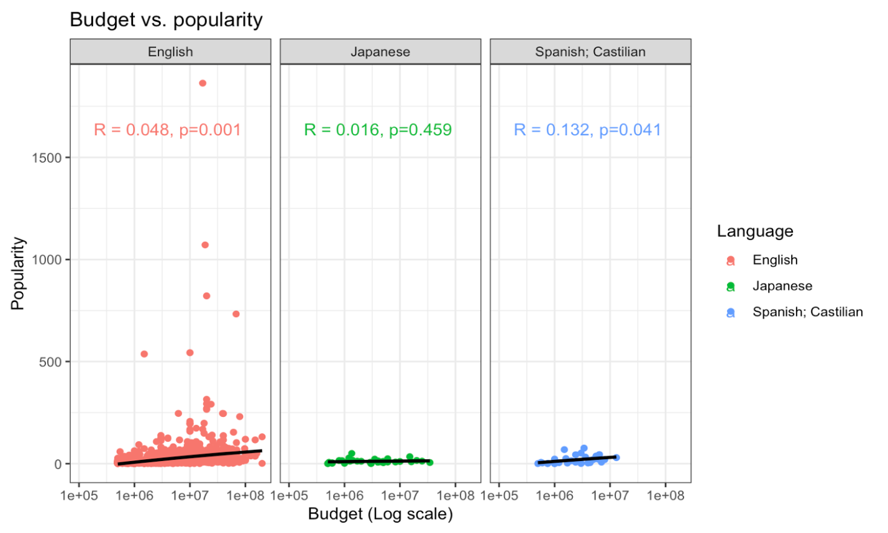
We have budget of the movies on X axis and its popularity on the Y axis. We looked into the top three language movies. Budget of movies in all three language were found to have a very low positive correlation with its popularity. However, only English movies showed a significant correlation.

